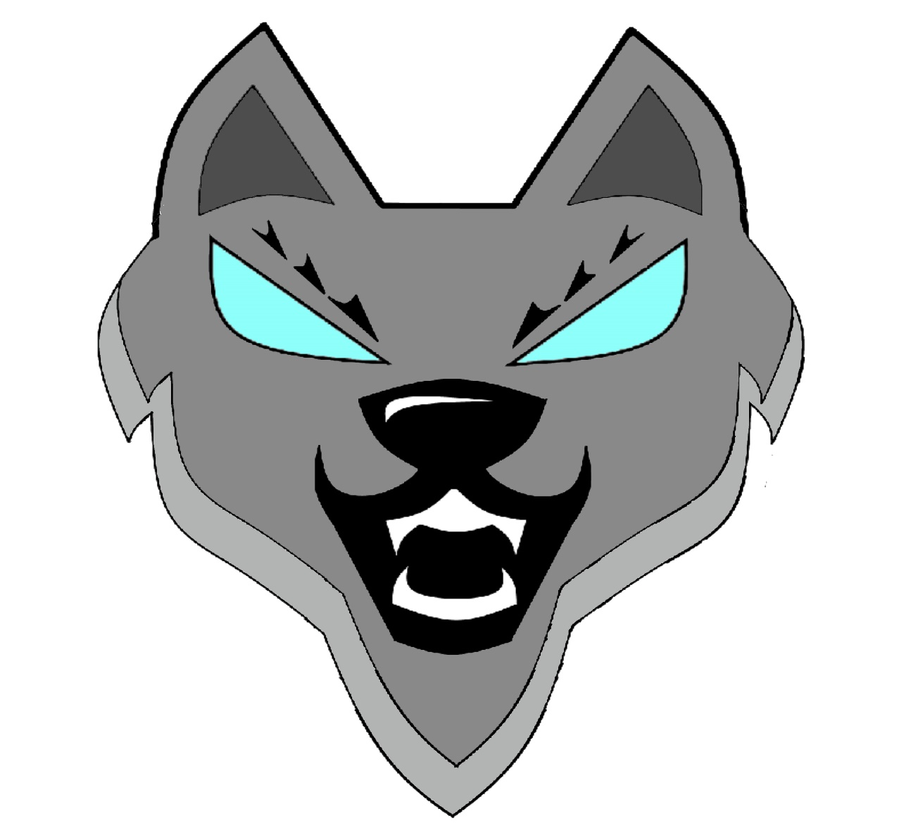

**Отбор Wolf**

Table of Contents

Information and Development of a plan 3

Team roles 3

Introduction 3

Milestones of realization 4

All tasks to perform 4

## Information and Development of a plan

**PRESENTATION OF THE PROJECT**

Our project is a Unity game on adventure thematic, which you can download from our repository.

Link - <https://github.com/codingburgas/2122-the-games--adventures-final_project_ous>

# Team roles

|  |  |
| --- | --- |
| № | Roles in the team |
|  | Velimir Dimitrov - Scrum Trainer |
|  | Yanislav Stoyanov - Scrum Trainer |
|  | Dimitar Bodurov - Scrum Trainer |
|  | Nikola Krushkov - Back-End Developer |
|  | Samuil Shkvarla - Back-End Developer |
|  | Angel Angelov - Front-End Developer |
|  | Ivan Delchilov - Front-End Developer |
|  | Miroslav Ganev - Front-End Developer |

### 

# Introduction

|  |  |
| --- | --- |
| № | Introduction |
|  | What is the product?  The product is a Unity application. |
|  | Where is it available?  Our collaborative work took place in **GitHub** and in order for the files to be accessible to everyone they were uploaded in the GitHub Repository of our project.  **Link** - <https://github.com/codingburgas/2122-the-games--adventures-final_project_ous> |
|  | Communication?  Communication is realized through **Teams**. |
|  | What technologies are used?  The technologies used are **Unity**, **Git** and **GitHub** for collaborative work. **Teams** - connection and communication, **MS** **PowerPoint** - preparing a Presentation, **MS** **Word** - preparing Documentation, **MS Excel –** preparing a QA Documentation . |

# Milestones of realization

|  |  |
| --- | --- |
| № | Milestones in realization |
| 1 | Form the team  Our team is formed by 8 people and everyone has its unique role. That role is determined according to his skills and knowledge. |
| 2 | Do research on the topic  To achieve our goals, we had to spend some of our time in researching. Research is an essential part of the project. |
| 3 | Discuss ideas  After doing some research on the topic, everyone suggested their idea, we discussed the ideas and assigned everyone some tasks. |
| 4 | Sort and separate tasks  Each of us has a unique role and the tasks he receives are determined according to it. The tasks are sorted in the Projects section in GitHub and are well described, so that everyone can understand what they are supposed to do. |
| 5 | Work on the project  After everyone received their tasks, we started working on the project. With hard work and a lot of effort, together we managed to create the final product. |

# All tasks to perform

|  |  |
| --- | --- |
| № | Completed tasks |
| 1 | Main Menu The design and functionality of the Main Menu was created by the Front-end developer. |
| 2 | Create a Documentation  Our Scrum trainer had the task to create a Documentation where the essence of our project is described in the best possible way. |
| 3 | Create Presentation  Our Scrum trainer was assigned the task to create a proper presentation which represents our team and our work. |

# 